

Software Requirement Specification

For

Mandayam Srivaishnava Sabha
Digital Library Application

Introduction

Scope
Digital Library Application where peoples can get study material. The main goal of the application is to provide study material in form of pdf, videos and audio files.

Version

Version | Date | Page # | Comments
1.0 | 29th May 2019 |  | Initial version created
1.1 | 1st June 2019 |  | Forms fields for manage authors added. User experience feedback form added
1.2 | 4th June 2019 |  | Changes in author’s form fields
1.3 | 12th June 2019 |  | Updated Version

Technologies

For Web Application [Admin Panel]

Operating System | Linux
Language | PHP
Framework | Code Ignitor
Database | MySQL

For Web Application [Members]

Operating System | Linux
Language | PHP
Framework | Code Ignitor
Database | MySQL

Stake Holders
Application will have the below user levels:
- Administrator
- User

Administration
Modules | Description
Log-In | - Log-In Page will consist of fields to enter Gmail id and password.  - Forgot password to recover the password, through Gmail id.
Dashboard | - Dashboard gives the information about the,  - New books this month  - New author this month  - Total Books  - Total Author
Manage Books | - Admin will upload digital material by filling below form fields.
Manage Author | - Admin can add / edit / delete the authors. The basic details provided in the form field.
Manage Setting  Category  Sub Category | - The category and sub category will be related to author’s type of content.  - Admin can add / edit / delete the category and sub category.  - Sub category will be linked with category selection.  - Admin can download and upload Metadata in  - bulk in form of excel sheet.
My Profile | - Admin will have an option to make changes in personal details & change password.
FAQ | - Admin will add FAQ for members
Note: Admin will receive the user experience submitted by user/s to the directed/recorded mail id.

Work flow of Super Admin

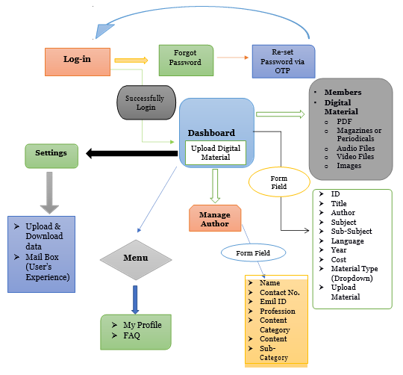

Admin from field

Login form field
Note: * has to be considered as mandatory fields.
Fields | Type validations | Values & Note
*Email ID/Mobile number | Textbox  Email Validation
*Password | Textbox  Password Validation
Note: Kindly share in case of any other field required in the User Form

Dashboard
New books this month
New author this month
Total Books
Total Author

My Profile
Note: * has to be considered as mandatory fields.
Fields | Type validations | Values & Note
*Name | Textbox [Auto filled & Editable]  Alphanumeric 25 characters only
*Mobile number | Textbox [Auto filled & Editable]  Alphanumeric 25 characters only
*Email | Textbox [Auto filled & Editable]  Email Validation
Submit

Change Password form field
Note: * has to be considered as mandatory fields.
Fields | Type validations | Values & Note
*Old Password | Textbox  Password Validation
*New Password | Textbox  Password Validation
*Confirm Password | Textbox  Password Validation
Kindly confirm if any values to add or alter in the form.

Manage Books
Note: * has to be considered as mandatory fields.
Fields | Type validations | Values & Note
*Book Name | Textbox  alpha count of 50 only
*Domain | Dropdown
*Author | Dropdown
*Category | Dropdown | Linked with author
*Sub-Category | Dropdown | Linked with author and category
*Published Date | Calendar Picker
*Format | Dropdown | View - For image  Listen – For Video  PDF – For Read
*Language | Textbox  alpha count of 50 only
Upload | Button  Validation based on Format [png, jpeg, mp4, mp3, pdf] | Value dependent on Format
Admin is allowed to perform actions as mentioned below,
- Edit
- Delete
- View
Admin is allowed to change the status of the records as mentioned below,
- Active
- Inactive

Manage Authors
Note: * has to be considered as mandatory fields.
Fields | Type validations | Values & Note
*Author Name | Textbox  alpha count of 50 only
BOD | Calendar Picker
Phone number | Number field  Number validation
Email | Textbox  Alphanumeric validation
*Category | Dropdown
*Sub-Category | Dropdown
*About Author | Text Area  Alphanumeric validation
*Author image | Upload  Image validation
Admin is allowed to perform actions as mentioned below,
- Edit
- Delete
- View
Admin is allowed to change the status of the records as mentioned below,
- Active
- Inactive

Manage Category
Note: * has to be considered as mandatory fields.
Fields | Type validations | Values & Note
*Author Name | Dropdown | Value to be fetched from Manage Authors
*Category | Textbox  Alphanumeric validation
Admin is allowed to perform actions as mentioned below,
- Edit
- Delete
- View
Admin is allowed to change the status of the records as mentioned below,
- Active
- Inactive

Manage Sub-Category
Note: * has to be considered as mandatory fields.
Fields | Type validations | Values & Note
*Author Name | Dropdown | Value to be fetched from Manage Authors
* Category | Dropdown | Value to be fetched from Manage Category
*Sub-Category | Textbox  Alphanumeric validation
Admin is allowed to perform actions as mentioned below,
- Edit
- Delete
- View
Admin is allowed to change the status of the records as mentioned below,
- Active
- Inactive

Manage FAQ
Note: * has to be considered as mandatory fields.
Fields | Type validations | Values & Note
*Question | Textbox  Alphanumeric validation
*Answer | Text Area  Alphanumeric validation
Admin is allowed to perform actions as mentioned below,
- Edit
- Delete
- View
Admin is allowed to change the status of the records as mentioned below,
- Active
- Inactive

Members

Modules | Description
Search | - Member will have search option  - Free text search (like Google)  - Search based on Title, Author, Category, Sub-Category, Domain etc.  - Book-mark a page in the PDF document and save it later.
Digital Material | - Member will be able to view digital material.  - They can save/download digital material offline.  - For audio & video files they will redirect to YouTube.
Experience | - Users will share their experience with admin.

User Work Flow
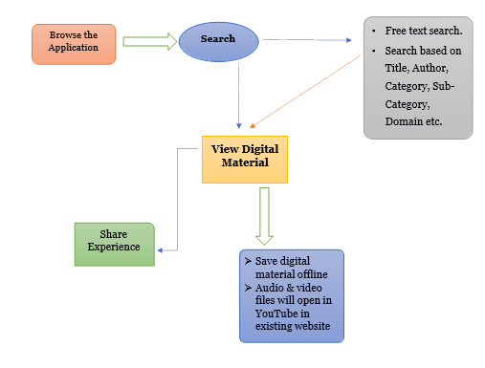

Admin from field

User Experience
Note: * has to be considered as mandatory fields.
Fields | Type validations | Values & Note
*Name | Textbox  Alphanumeric validation
*Phone number | Number field  Number validation
*Email ID | Text box  Alphanumeric validation
*Comment | Text Area  Alphanumeric validation
Admin is allowed to perform actions as mentioned below,
- Edit
- Delete
- View
Admin is allowed to change the status of the records as mentioned below,
- Active
- Inactive

